TRACE 1:

Q1. SNMP, TCP, HTTP, DNS

Q2. 

The frame numbers being sequential, indicates that the corresponding frame 10 GET has Frame 12 as its OK reply. Hence in order to calculate the time taken to GET and OK is 12 4.718993 - 4.694850 = 0.02414300000000047 seconds

Q3.   
It was unsuccessful because its corresponding Frame 14 of relative 13, gives a 404 response, indicating unsuccessful transfer and retrieval.

Q4. Both are running HTTP 1.1



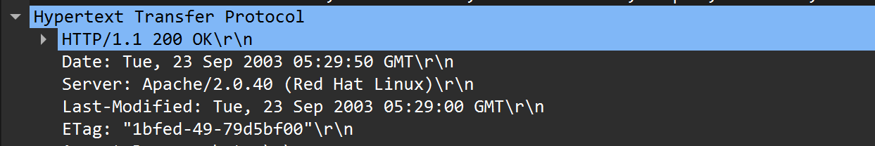

Q5. 

English as stated above.

Q6. 

This is the Get Request indicating the Src as my computer and Dst as my Server Host.



And Vice Versa for above.

Q7. 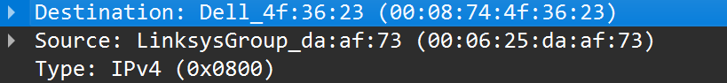

Destination is my computer and Source is the server (Taken from Response Request)

Q8. Port 80 is the port number assigned to commonly used internet communication protocol, Hypertext Transfer Protocol (HTTP). It is the default network port used to send and receive webpages.



Q9. HTTP/1.1 200 OK (text/html) HTTP/1.1 404 Not Found (text/html)

Q10. Tue, 23 Sep 2003 05:29:00 GMT

Q11. 439 Bytes

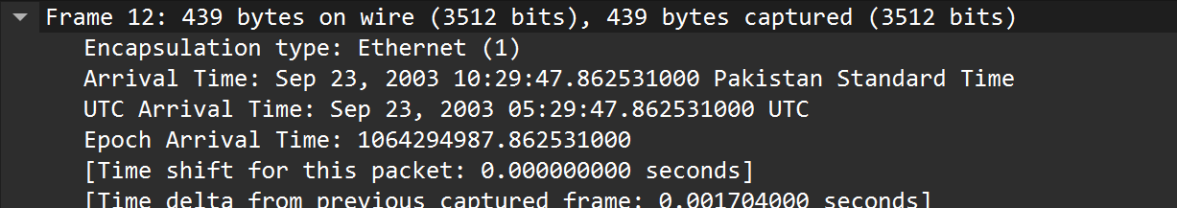

TRACE 2:

Q1. NO.

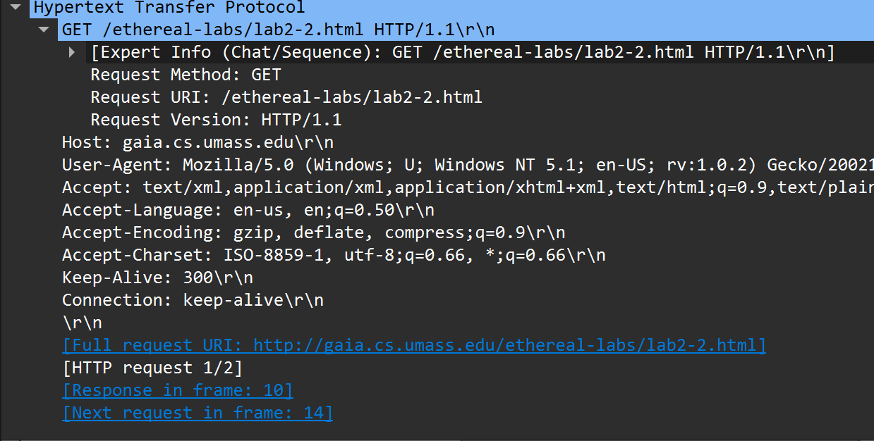

Q3. Yes. The If-Modified-Since header is a request-header that is sent to a server as a conditional request. The If-Modified-Since request HTTP header makes the request conditional: the server sends back the requested resource, with a 200 status, only if it has been last modified after the given date.

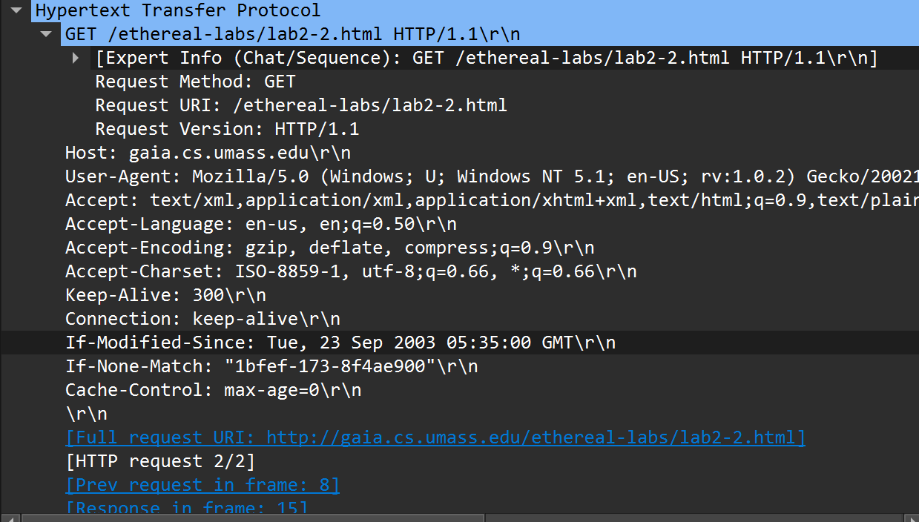

Q2. Yes its received.  
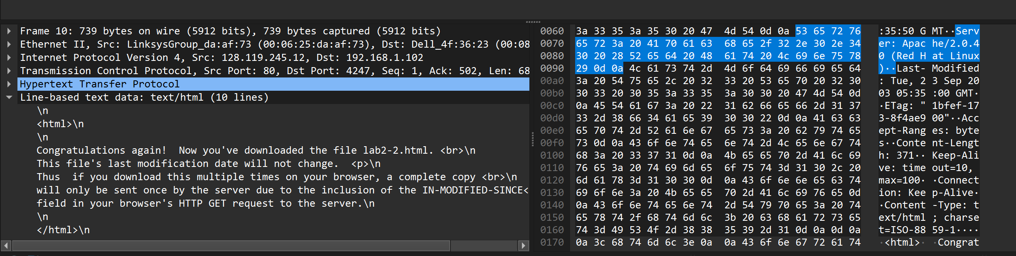

Q4. HTTP/1.1 304 Not Modified. No it did not return the contents of the requested file because the data has not been modified after the given date.

Q5. One only.



Q6.Packet Number 8

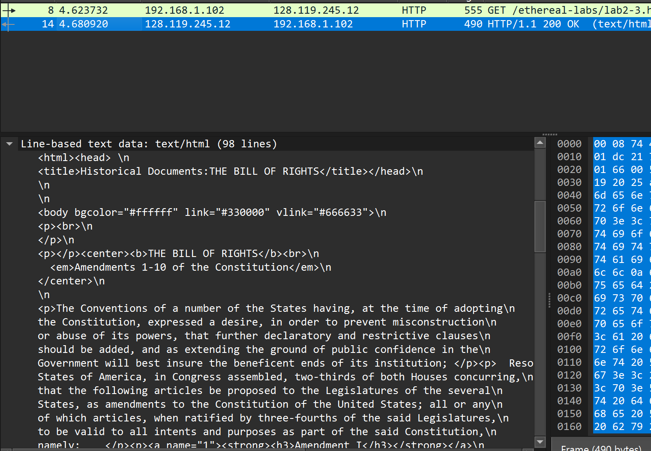

Q7. Packet Number 14

14 4.680920 128.119.245.12 192.168.1.102 HTTP 490 HTTP/1.1 200 OK (text/html)

Q8. HTTP/1.1 200 OK (text/html)

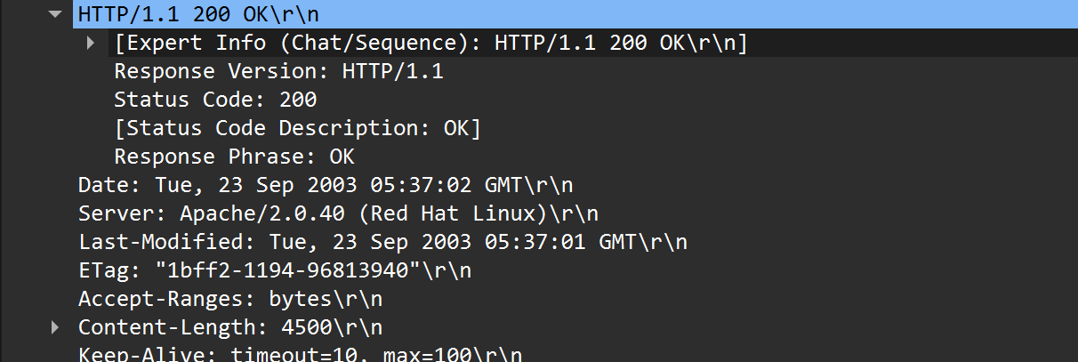

Q9. 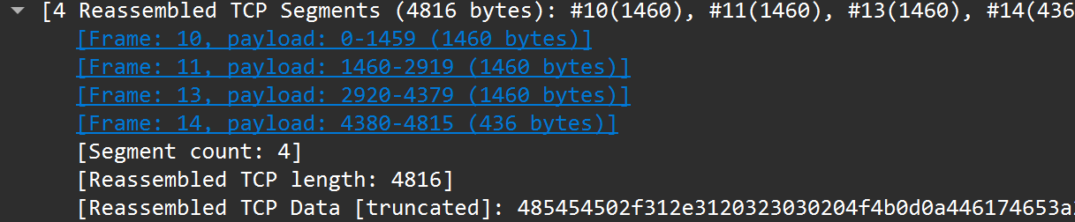

TRICK QUESTION:

Due to multiple protocols being engaged and them causing their own overhead along side the segmentation of retrieved packets, the overall size exceeds 4500 to 4816 causing a greater value than the expected size. Moreover, 490 is the packet limit for the last frame received whereas the frame received before that are 1516 in size limit.